Experiment-16

Aim: To write PL/SQL program to implement Cursor on table.

Table creation : 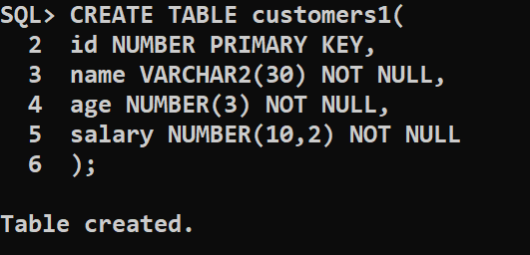

INSTANCE OF TABLE : 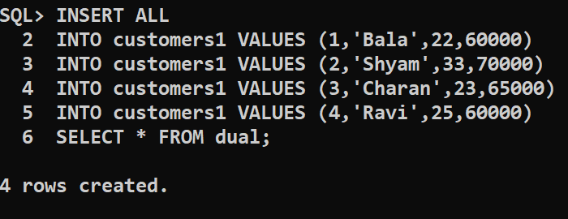

Create procedure: 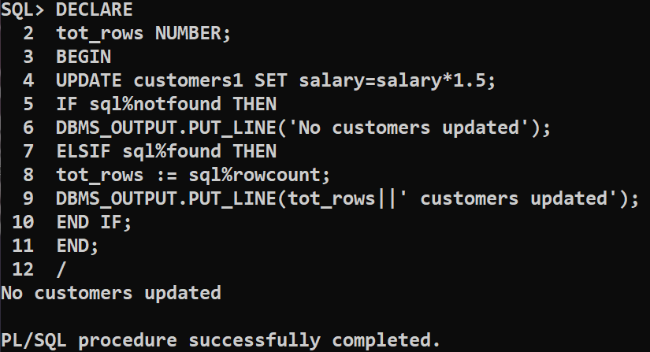

PL/SQL Program using Explicit Cursors:

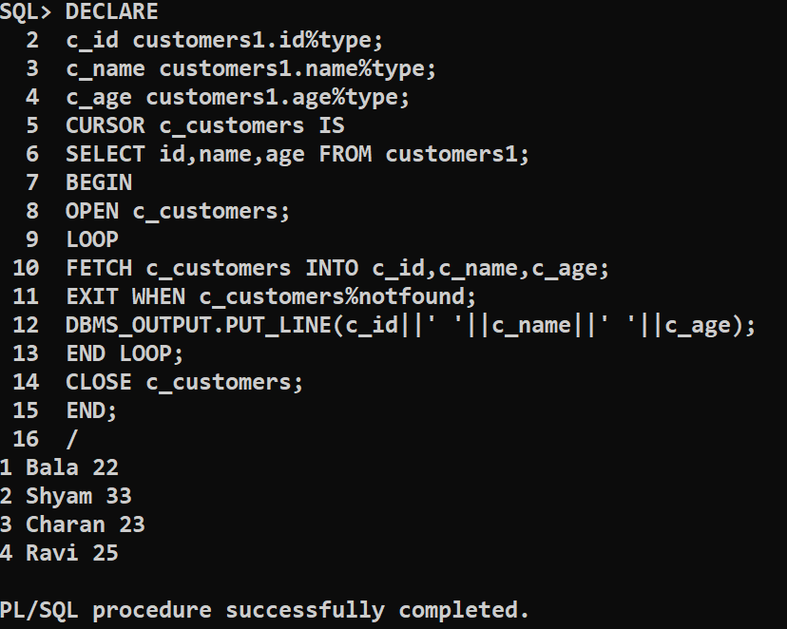

CONCLUSION : The PL/SQL program to implement Cursor on table is successfully executed.